K8S Linux Centos 7 安装

安装以：一个Master，一个Node为例

**通用安装：yum -y install epel-release**

## 一、Master安装：

### 1.关闭防火墙：

systemctl stop firewalld

systemctl disable firewalld

setenforce 0

firewall-cmd –state

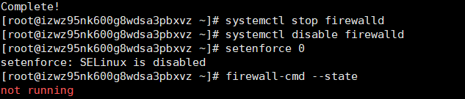

### 2.安装master

yum -y install etcd kubernetes-master

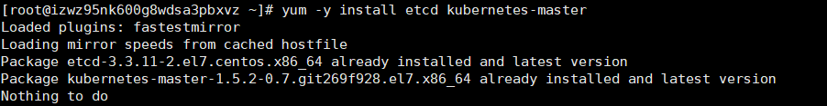

*注：我这里已经安装*

### 3.修改配置

#### 3.1 ectd配置

vi /etc/etcd/etcd.conf

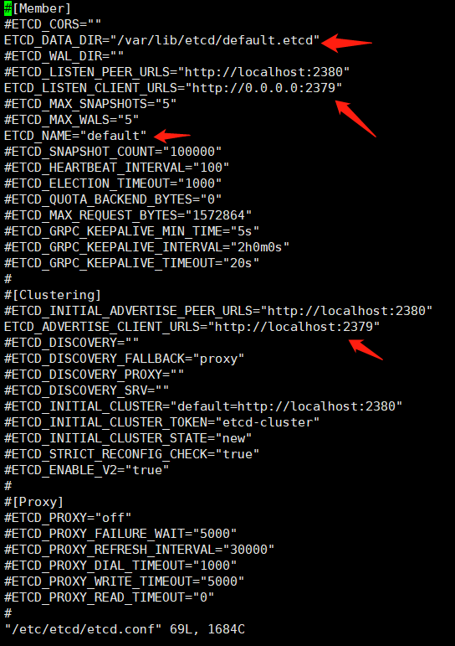

#### 3.2 apiserver配置

vi /etc/kubernetes/apiserver

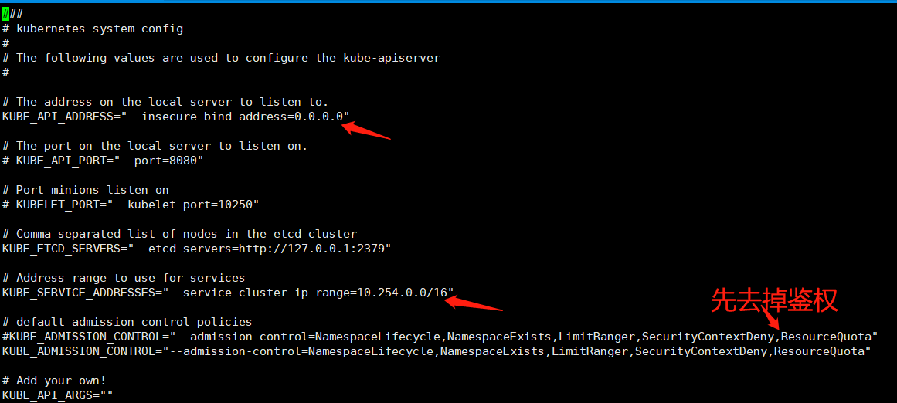

### 4.启动：

参考脚本：



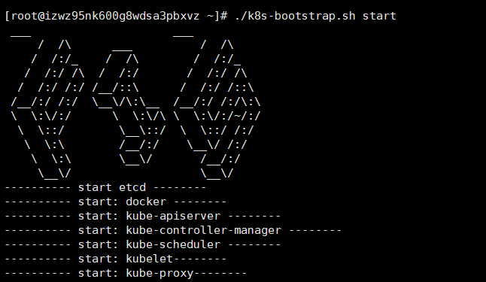

另：

|  |
| --- |
| for SERVICES in etcd kube-apiserver kube-controller-manager kube-scheduler; do systemctl restart $SERVICES;systemctl enable $SERVICES;systemctl status $SERVICES ; done |

### 5. 创建flannel网络

Node端用到，需要启动k8s后

etcdctl mk /atomic.io/network/config {'"Network":"172.17.0.0/16"'}



## 二、Node安装

注：请记得通用安装更新yum源：yum -y install epel-release

### 1.安装node:

yum -y install flannel kubernetes-node

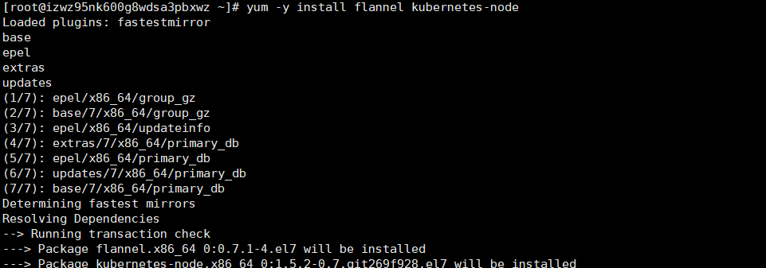

### 2.配置修改:

#### 2.1 flannel网络修改

vi /etc/sysconfig/flannel

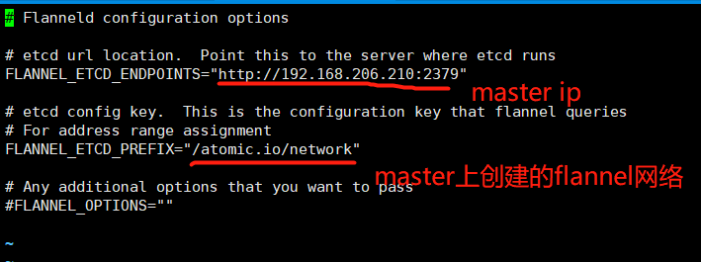

#### 2.2 node配置修改：

vi /etc/kubernetes/config

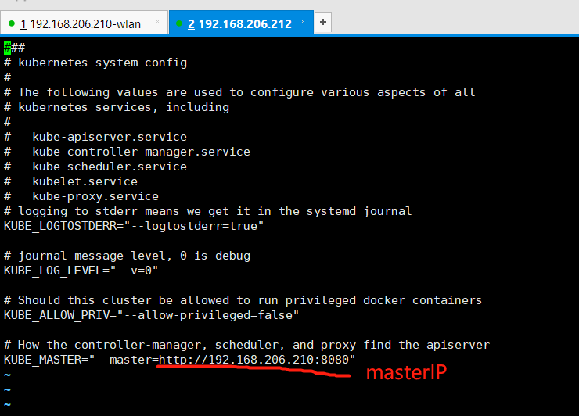

#### 2.3 kubelet配置修改

vi /etc/kubernetes/kubelet

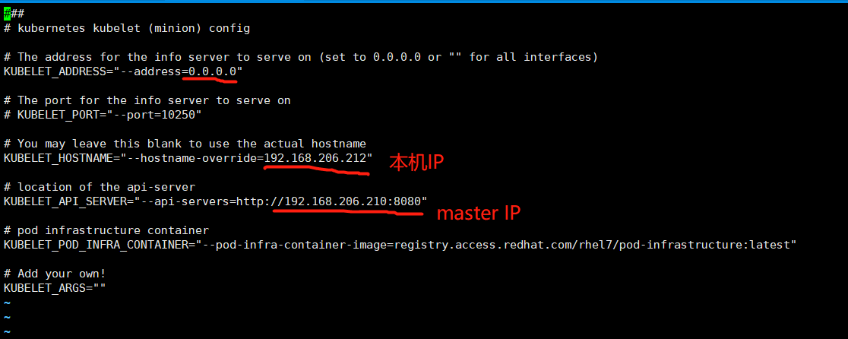

### 3.启动：

参考脚本：



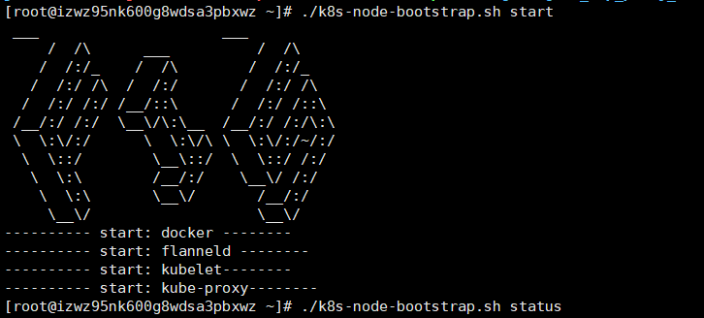

其他：

|  |
| --- |
| for SERVICES in kube-proxy kubelet docker flanneld;do systemctl restart $SERVICES;systemctl enable $SERVICES;systemctl status $SERVICES; done |

### 4. master服务上查看集群情况

kubectl get nodes

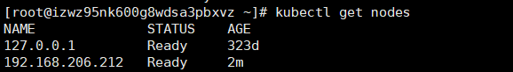

注：如果出现not ready状态，及时查看node的启动情况